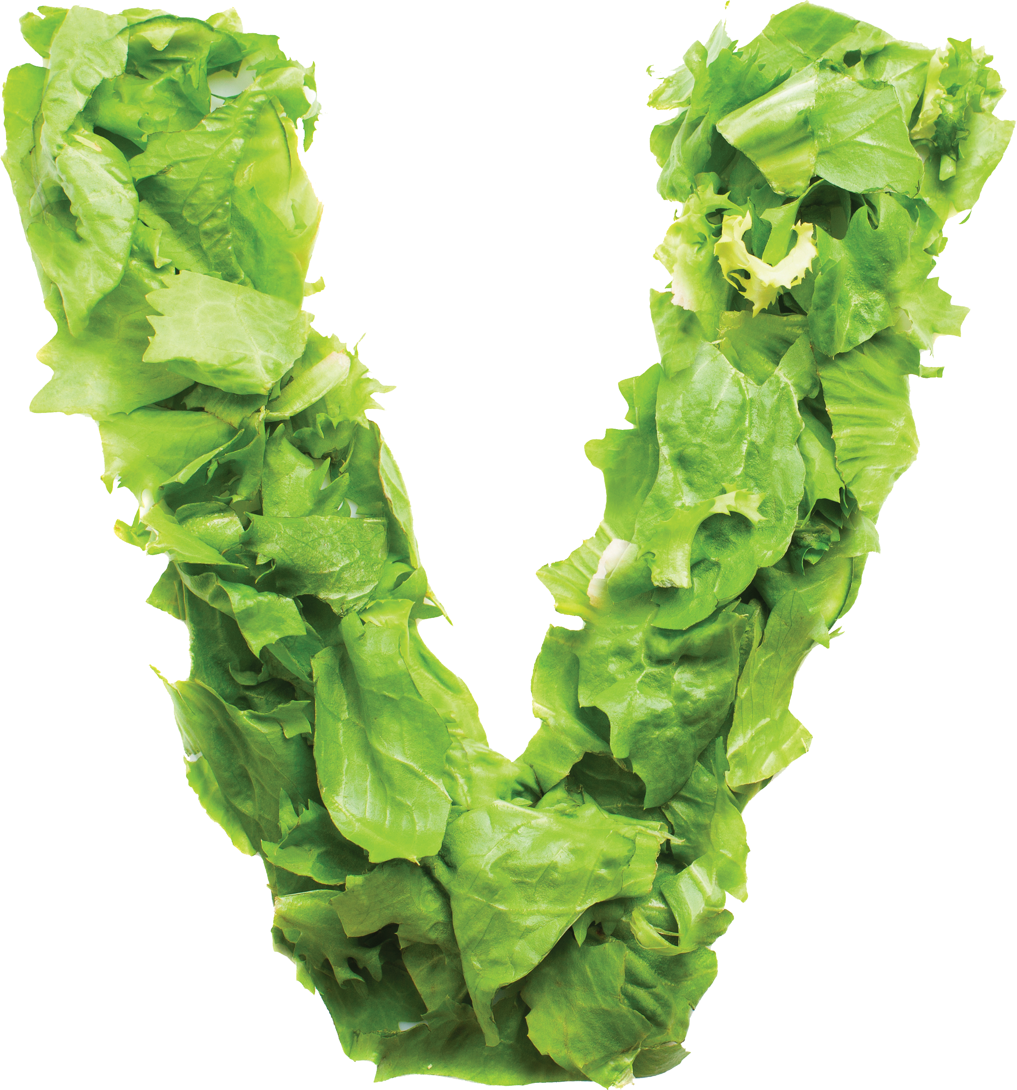Entrees
Stir fried with green bean,
bell pepper and prik khing curry sauce.
GF
GINGER HEAT
Stir fried with garlic and black pepper sauce served on top of sauteed mixed vegetables.

PAD PRIK POA
Stir fried with broccoli, peapod, baby corn, onion, bell pepper, mushroom,sweet basil
and carrot with sweet shrimp paste.
GF
GARLIC PEPPER
Stir fried with mixed vegetables with light brown sauce.
GF
VEGGIE DELIGHT
Stir fried with bell pepper,
onion, spicy chili sauce, and sweet basil.
GF
HOLY BASIL
All served with your choice of protein, and a side of jasmine rice $11

Chef Specialties
All served with a side of jasmine rice
Your choice of deep fried chicken breast or grilled jumbo shrimp served on sauteed cabbage and carrots with house special sauce.
TILAPIA w th PINEAPPLE or RED CURRY SAUCE $15
Deep fried Tilapia topped with Pineapple sauce, or Red curry sauce.

ANDAMAN KAREE $17
Squid, shrimp, sea scallop, mussel, bell pepper, onion, celery and green onion, stir fried with curry powder, egg and coconut milk.
GF
VOLCANO CHICKEN $14/ SHRIMP $17
HAWAIIAN DELIGHT $12
Stir fried chicken and shrimp with white onion, pineapple, cucumber, tomato and bell pepper, with sweet and sour sauce.
3 MUSKETEERS $11
Deep fried chicken strip topped with pineapple sauce, accompanied by sauteed bell pepper, onion, carrot and pineapple.
MIGHTY CASHEW $11
Stir fried crispy chicken with onion, green onion, water chestnut, mushroom, bell pepper and crunchy cashew nut in a sweet brown sauce.
CHICKEN / BEEF TERIYAKI $11
Grilled chicken or beef glaze with special teriyaki sauce served with steamed mixed vegetables.
Stir Fried Rice & Noodles
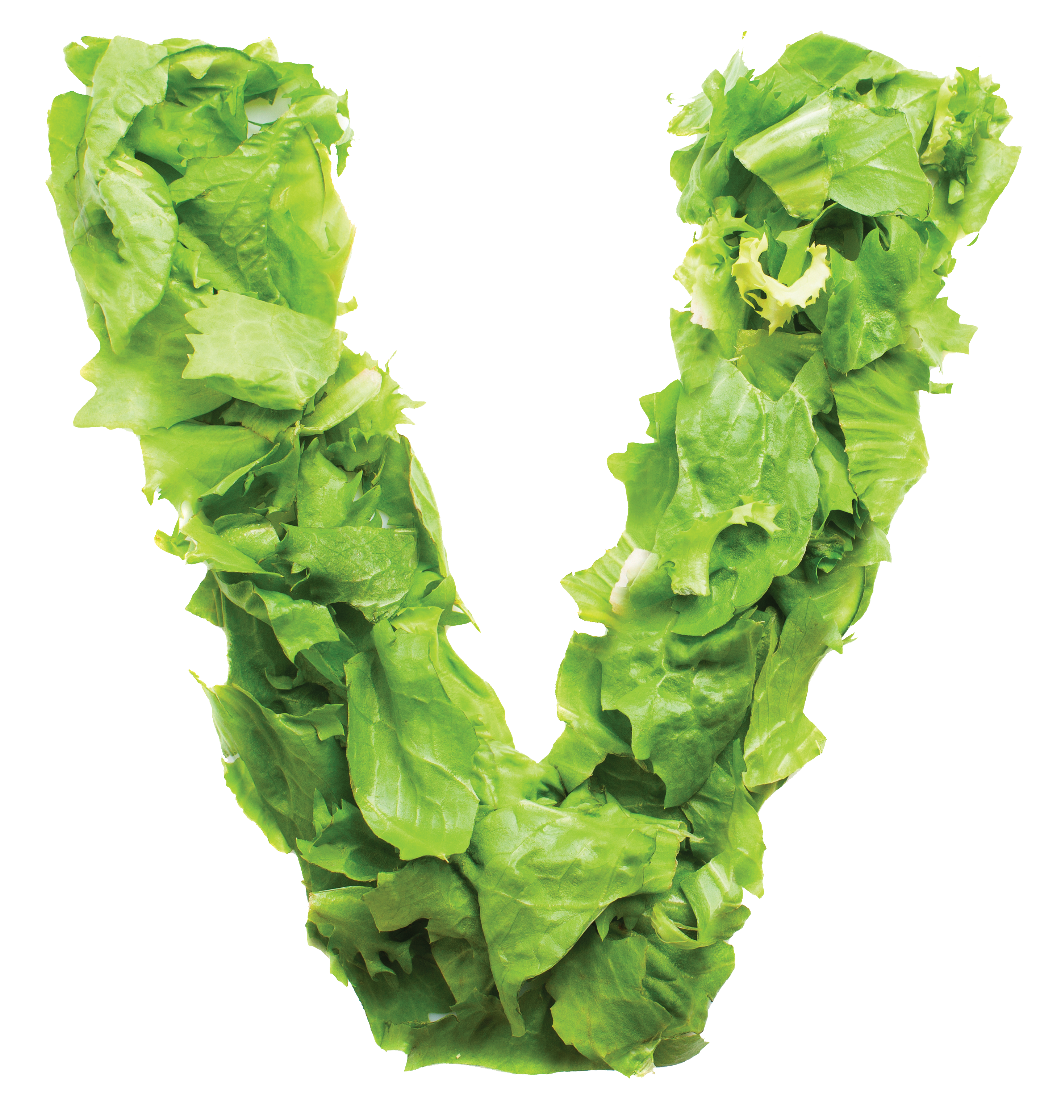 All served with your choice of protein $11
Stir fried udon noodles with bell pepper, chili pepper, white onion, holy basil, bean sprout, baby corn, carrot, broccoli, peapod and mushroom.
GF
DRUNKEN NOODLE
Stir fried wide rice noodle with egg and broccoli in brown sauce.
GF
PAD SEE EW
Thin rice noodles stir fried with egg, bean sprout, green onion, and crushed peanut, wrapped in
a thin pan fried egg.
GF
WRAP-A-PAD THAI
GF
THAI-NAMITE FRIED RICE
Stir fried rice with egg, spicy shrimp paste, green onion,
mushroom, tomato, white onion and carrot.
Stir fried rice with egg,
white onion, green onion and tomato.
HAWAIIAN FRIED RICE
Stir fried rice with egg, white onion, tomato, green onion,
curry powder, cashew nut and pineapple.
GF
CLASSIC FRIED RICE

Sides

STEAMED VEGETABLES $3 JASMINE RICE/SUSHI RICE/ROTI $2 BROWN RICE $3
i
Soup &
MISO SOUP $2.5
Soybean soup with scallions, seaweed and soft tofu.
TOM KHA $4
Choice of chicken, shrimp, tofu, or veggie with cabbage and mushroom in a creamy coconut soup, flavored with galangal and lime juice.
TOM YUM $4
Hot and sour soup with your choice of shrimp, chicken, tofu, or veggie with mushroom, tomatoes, lemon grass,lime juice, and sweet shrimp paste.
VEGGIE SOUP $3.5
Mixed vegetables and tofu in a clear broth.
CUCUMBER SALAD $3
Sliced fresh cucumber drizzled with sweet and sour dressing.
BEEF SALAD $8
Grilled New York strip steak served over mixed greens, cucumber, onion and tomato, drizzled with ginger dressing.
SHRIMP OR SQUID SALAD $8
Choice of shrimp, squid or combination, with lemongrass, onion, green onion, mint leaves and sweet shrimp paste, garnished with crispy noodle.
SEAWEED SALAD $5
Marinated seaweed served with mirin vinaigrette and cucumber.
All served with
Curry
your choice of protein,
GF
THAI-NAMITE CURRY (massaman) $12
Chunk of beef with onion, potato, carrot, and cashew nut in coconut milk and Mussaman curry sauce. Choice of rice or roti.
Bamboo shoots, bell peppers, and sweet basil leaves in coconut milk and red curry sauce.

YELLOW CURRY
Potato, onion and tomato in coconut milk and yellow curry sauce.
GF
RED CURRY
Green beans and bell peppers in coconut milk and panang curry sauce.
GF
PANANG CURRY
Green beans, bamboo shoots, bell peppers, and sweet basil leaves in coconut milk
and green curry sauce.
and a side of jasmine rice $11
GREEN CURRY GF
STEAMED NOODLES/CRISPY NOODLES $2 EXTRA MEAT/VEGETABLES/TOFU $2 PEANUT SAUCE $1
SPICY MAYO or UNAGI SAUCE $1 TERIYAKI or VOLCANO SAUCE $3/ 8 oz WASABI/PICKLED GINGER $0.50 PLUM SAUCE $0.50

18% service charge is included for parties of 5 or more prices are subject to change without prior notice
Please inform us if you have an allergy or gluten intolerance / restrictions. We cannot promise / guarantee the cross - contact of products

Choice of Protein
CHICKEN, PORK, TOFU, VEGGIE BEEF (+$1) SHRIMP (+$2)
*Consuming raw or undercooked meats, poultry, seafood, shellfish, or eggs may increase your risk of foodborne illness.

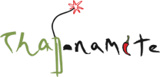

Visit 3 locations of Us
East Side Brady St/Milwaukee Public Market/Wauwatosa
Add spice to any dish!
1 SPICY / 2 HOT / 3 NATIVE THAI
Contains Nuts
Can be prepared gluten free- please alert your server.
Can be prepared vegan- no egg, fish sauce or meat.
GF

TOSA

SPRING ROLLS (2)
Deep-fried spring roll shell stuffed with ground pork, carrot, glass noodle, cabbage, and mushroom,
served with plum sauce / $4.50
TUNA TARTARE
Diced tuna, avocado, white and green onion, citrus vinaigrette, sesame oil, sweet soy sauce, served with crispy wonton / $9
GYOZA (5)
Japanese dumpling filled with pork and vegetables served with citrus soy sauce / $5
CRISPY SQUID
Deep-fried squid served with plum sauce topped with
crushed peanuts /$7
EDAMAME
GF
GOLDEN SQUARE
Deep-fried tofu, served with plum sauce, topped with fresh peanuts /$5
GF
FRESH ROLLS (2) GF
Fresh rice sheet stuffed with fried egg, tofu, rice noodle, green lettuce and cucumber, served with chef’s special peanut sauce topped with crushed peanuts /$4.50
CHICKEN SATAY (3)
Grilled chicken tenderloin marinated in curry powder and coconut milk, served with a side of creamy peanut sauce and a refreshing cucumber relish /$7

GREEN BAY PACKER*
Smoked salmon, cream cheese,
Nigiri/Sashimi
Nigiri/ sashimi comes in 2 peices.
..........................................................................................................................................................................................................................................................

jalapeño and cilantro, topped with avocado, unagi sauce and lemon sauce. / 15
Signature Maki

RED DRAGON*
Spicy shrimp and cucumber, topped with tuna, relish sauce, and unagi sauce. /14

TOSA
Beet, Japanese pumpkin, asparagus tempura, and avocado, drizzled with wasabi mayo
and sweet soy sauce. / 13

MILWAUKEE
Shrimp tempura, cream cheese, green onion, sriracha sauce, masago mayo, avocado, tempura crumbs,
unagi sauce, wasabi mayo. / 15

THAI-NAMITE*
Octopus, cilantro, jalapeno, crab stick topped with shrimp and tom yum
sauce. / 15

SMOKEY BEAR*
Unagi, cream cheese, cucumber topped with smoked salmon, and spicy honey sesame sauce. / 14
KAMIKASE*
Deep fried roll of spicy tuna, asparagus topped with spicy mayo and
sweet soy sauce. / 12

ASTOR*
Salmon, crab stick, cucumber topped with seared super white tuna, and wasabi mayo. / 13

SUMMER*
Crab stick, cucumber, asparagus topped with salmon, and lemon sauce. / 14

Sushi ntrees
E
Sushi entree serve with miso
SUSHI DELUXE*
SUSHI SUPREME*
6 pieces of nigiri and
rainbow maki (roll).
/ 23
SAKE (salmon)* /$6 SUZUKI (sea bass)* /$5 TAKO (octopus)* /$5
TAMAGO (Japanese omelette)* /$4 TOBIKO (flying fish roe)* /$5 UNAGI (fresh water eel) /$6 MADAI (red snapper)* /$7 IKURA (salmon roe)* /$6
INARI (soybean pocket) /$4 KAJIKI (escolar)* /$6
Maki

ALASKAN* $6
Salmon, crab stick, avocado.

BOSTON* $6
Tuna, avocado.

PHILLY* $6
Smoked salmon, cream cheese.

SALMON SKIN $6
Salmon skin, cucumber, avocado, spicy mayo.

SPICY SALMON* $6
Salmon, spicy mayo.

CREAMY* $6
Super white tuna, avocado, masago mayo.

MARSHALL* $6
Hamachi, cilantro, ginger.

SPICY TUNA* $7
Ground tuna, spicy mayo, masago.

BRADY* $7
Ground spicy tuna, tempura crumbs, and unagi sauce.

AVOCADO. $5
MIXED VEGGIE $7
Lettuce, cucumber, avocado, asaparagus, shiitake.
AMA EBI (sweet shrimp)* /$8 EBI (shrimp) /$5
H AMACHI (yellow tail)* /$6 H OKKIGAI (surf clam)* /$5
H OTATEGAI (scallop)* /$7 IKA (squid)* /$5 MAGURO (tuna)* /$6
KANI KAMA (crab stick) /$5 KUNSAI SAKE (smoked salmon)* /$6 MASAGO (smelt roe)* /$5

CALIFORNIA* $7
Crab stick, cucumber, avocado, masago.

EBI TEMPURA $8
Shrimp tempura, avocado, cucumber, spicy mayo, and unagi sauce.
CRUNCHY $10
Shrimp tempura, cream cheese, asparagus, tempura crumbs, unagi sauce.
DRAGON $13
Shimp tempura, masago mayo topped with unagi, avocado, unagi sauce.

SPICY SHRIMP $9
Boiled shrimp, spicy mayo, scallion, tobiko.
MEXICAN* $10
Tuna, hamachi, cilantro, jalapeño, avocado.

NEW YORK $8
Eel, avocado, tempura crumbs, unagi sauce.
OREO* $9
Super white tuna, shiitake, black tobiko.

7 pieces of nigiri and spicy tuna
KAPPA $5

SPICY SCALLO P* $9

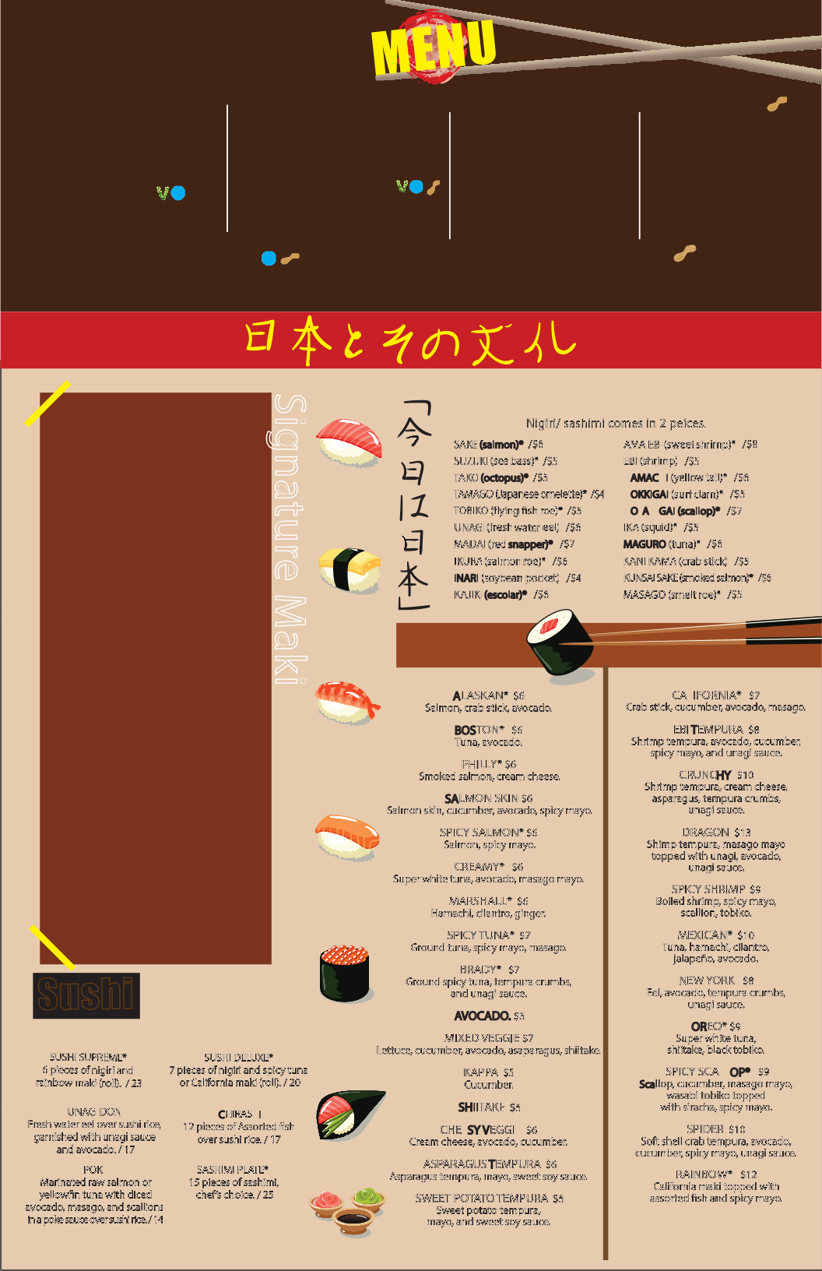
TEMPURA
Deep-fried shrimp and mixed vegetables served with house tempura sauce /$8.25
CRAB RANGOON (4)
Deep-fried wonton filled with imitation crab, cream cheese and minced onion, served with plum sauce /$6
Steamed Japanese soy bean pods, sprinkled with salt /$5.25
S_{tarters}

UNAGI DON
Fresh water eel over sushi rice, garnished with unagi sauce and avocado. / 17
POKE
Marinated raw salmon or yellowfin tuna with diced avocado, masago, and scallions in a poke sauce over sushi rice. / 14
or California maki (roll). / 20

CHIRASHI
12 pieces of Assorted fish over sushi rice. / 17

SASHIMI PLATE*
15 pieces of sashimi, chef’s choice. / 25
Cucumber.

SHIITAKE $5
CHEESY VEGGIE $6
Cream cheese, avocado, cucumber.

ASPARAGUS TEMPURA $6
Asparagus tempura, mayo, sweet soy sauce.

SWEET POTATO TEMPURA $5
Sweet potato tempura, mayo, and sweet soy sauce.
Scallop, cucumber, masago mayo, wasabi tobiko topped
with siracha, spicy mayo.
SPIDER $10
Soft shell crab tempura, avocado, cucumber, spicy mayo, unagi sauce.
RAINBOW* $12
California maki topped with assorted fish and spicy mayo.

